***San Marzano 50 Anniversario***

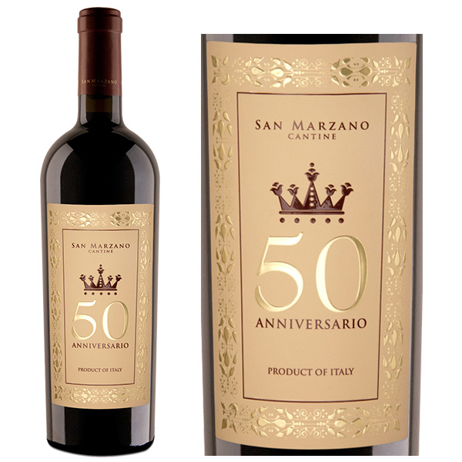

*This 50 Anniversario is to celebrate the 50th anniversary of the prestigious Cantine Sanmarzano distillery with a limited edition of only 7,500 annually, with two grape varieties Primitivo and Negro Amaro with 60-80 year old vines grown in the Sava region , Sanmarzano, grapes are left to ripen almost dry on the tree and then harvested. When harvesting, it has to be done by hand and in the early morning the grapes are at their best*